Contents
1) Design Electronic Stability Control Systems By Using The Following Methods: 3
1.1)Conventional yaw stability control(PI, PID, etc.) 3
1.2)Direct Yaw Moment Control (Only Upper Consider Controller Part And Use Single Track Model) 7
1.3)Disturbance observer (model regulator) based yaw stability control 8
2)Design A Vehicle Side Slip Angle State Observer 11
2.1 Check Observability 11
2.2 Perform simulations for zero and nonzero initial conditions and report them. 12

Design Electronic Stability Control Systems By Using The Following Methods:
Conventional yaw stability control(PI, PID, etc.)
Direct Yaw Moment Control (Only Upper Consider Controller Part And Use Single Track Model)
Disturbance observer (model regulator) based yaw stability control

1.1)Conventional yaw stability control(PI, PID, etc.)
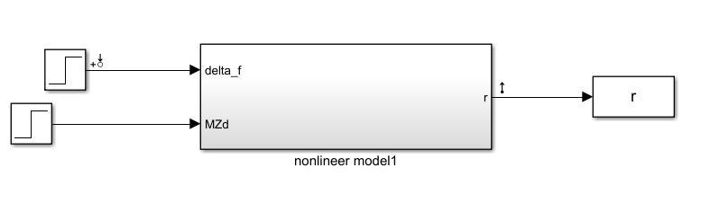
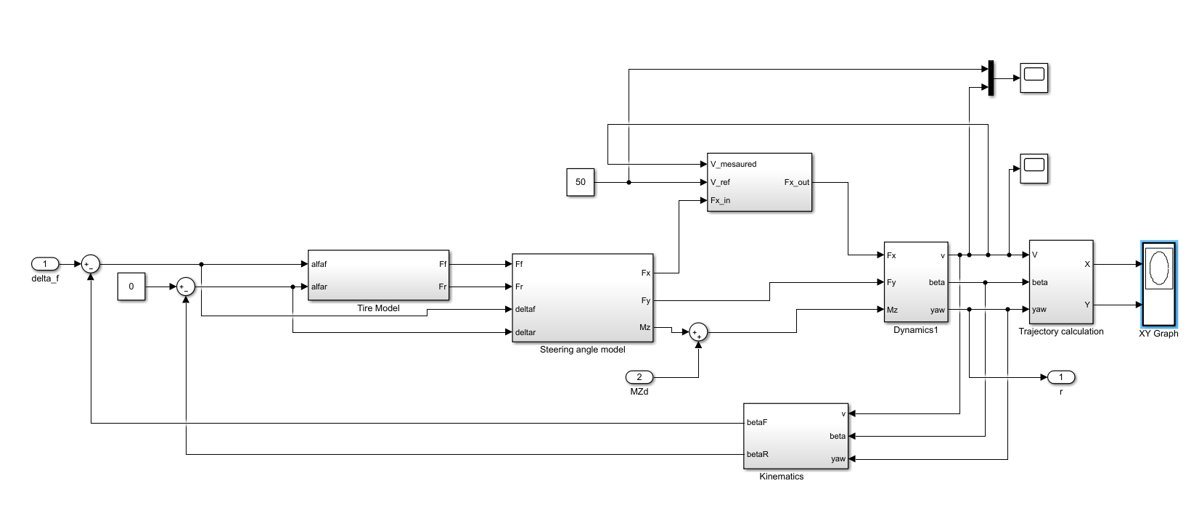

clear all
clc
mdl = 'Conventional_yaw_stability_pid_control';
open_system(mdl);
io = getlinio(mdl);
linsys = linearize(mdl,io)

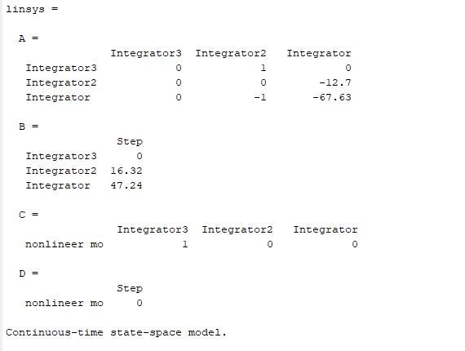

A=[0 1 0; 0 0 -12.7; 0 -1 -67.63];
B=[0;16.32;47.24];
C=[1 0 0];
D=0;
[num,den]=ss2tf(A,B,C,D);
tf(num,den)

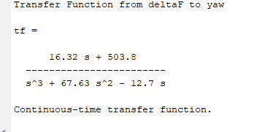
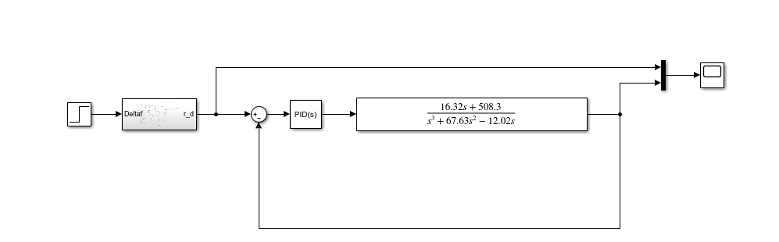
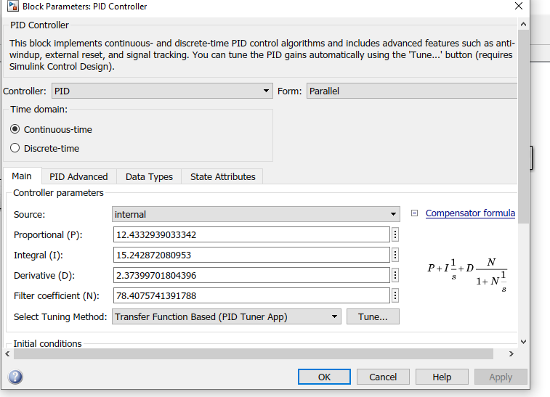
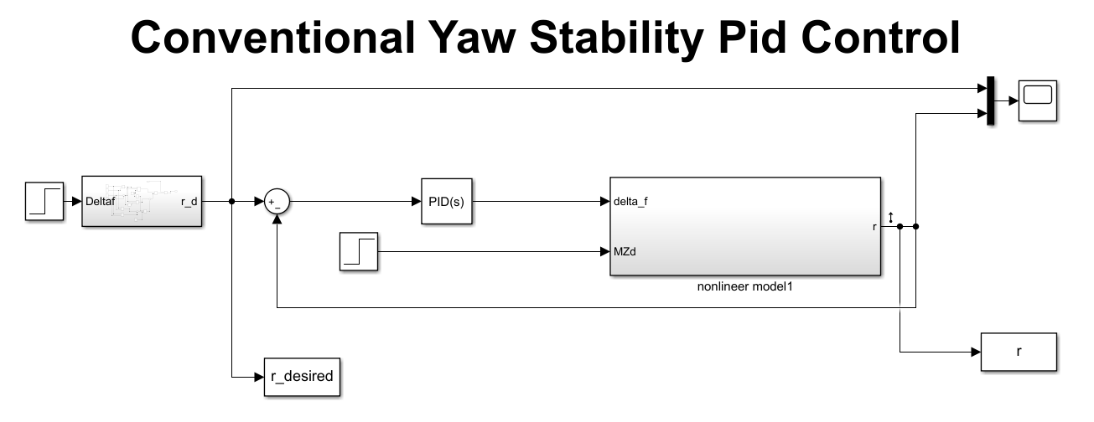
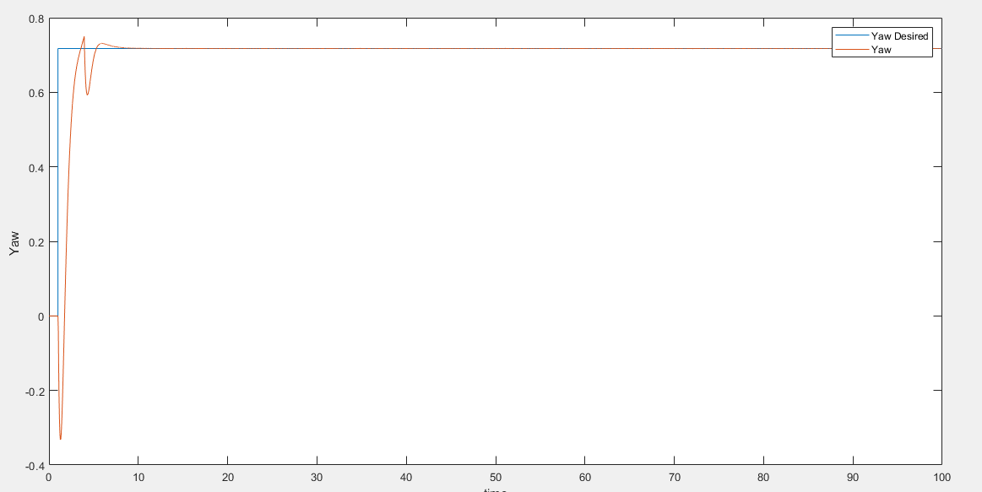
There is non minimum phase

1.2)Direct Yaw Moment Control (Only Upper Consider Controller Part And Use Single Track Model)
cr=198000;
cf=470000;
Mz=1000;
DeltaF=1;
lf=3.67;
lr=1.93;
m=9950;
mu=0.8;
v=80;
Iz=5;
A1=[(-mu*cf-mu*cr)/(m*v) -1+((mu*cr*lr-mu*cf*lf)/(m*v^2))];
A2=[(mu*cr*lr-mu*cf*lf)/(Iz) (-mu*cf*lf^2-mu*cr*lr^2)/(Iz*v)];
A=[A1;A2];
B=[(mu*cf)/(m*v) 0;(mu*cf*lf)/(Iz) 1/Iz];
C=[1 0;0 1];
D=[0 0;0 0];
Q=[1 0;0 10000]; % icrease to weight of x2 compared to x1
R=[0.1 0;0 0.1]; % reduced the energy weight t small value
K=lqr(A,B,Q,R)

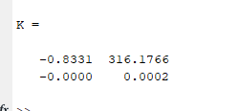
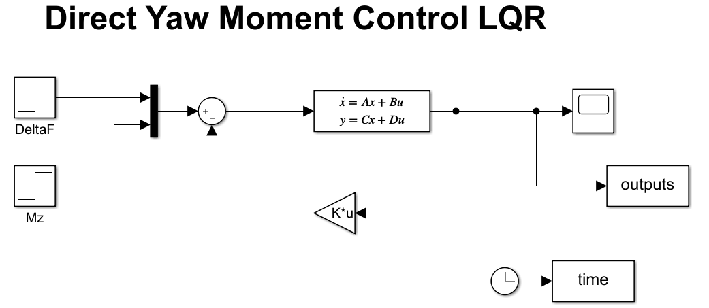
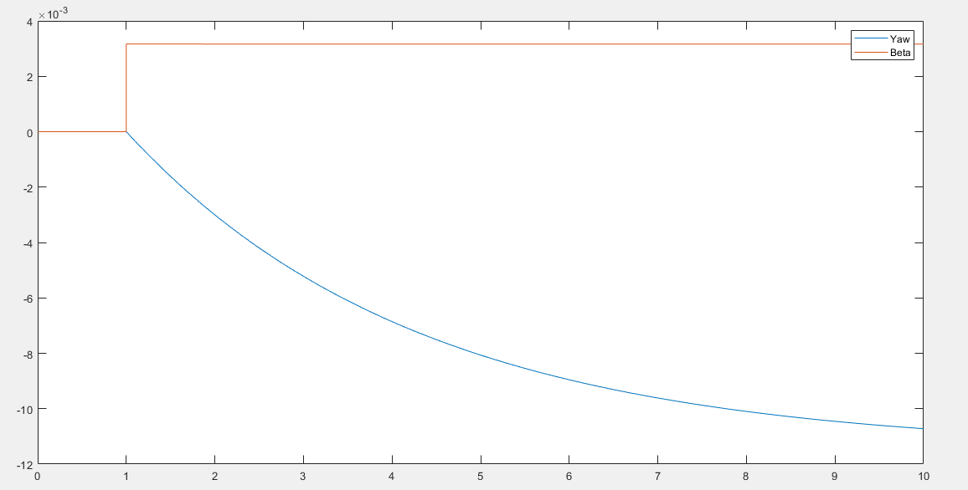

1.3)Disturbance observer (model regulator) based yaw stability control

$$G=\frac{16.32s+503.8}{s^{3}+67.63s^{2}-12.7s}$$
$$G_{n}=\frac{K_{n}}{τ_{n}s+1}=\frac{0.717}{0.01s+1}$$
$$\left| Q\right|<\left| \frac{1}{Δ_{m}}\right|$$
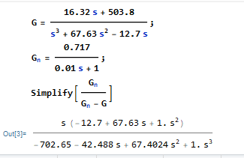
tf1=tf(b,a)
Q=tf([1],[0.01 1])
bode(tf1,Q)

2)Design A Vehicle Side Slip Angle State Observer

2.1 Check Observability
clc
clear all
cr=198000;
cf=470000;
Mz=1000;
DeltaF=1;
lf=3.67;
lr=1.93;
m=9950;
mu=0.8;
v=80;
Iz=5;
A1=[(-mu*cf-mu*cr)/(m*v) -1+((mu*cr*lr-mu*cf*lf)/(m*v^2))];
A2=[(mu*cr*lr-mu*cf*lf)/(Iz) (-mu*cf*lf^2-mu*cr*lr^2)/(Iz*v)];
A=[A1;A2];
B=[(mu*cf)/(m*v) 0;(mu*cf*lf)/(Iz) 1/Iz];
C=[0 1];
x=obsv(A,C)
chc_obs=length(A)-rank(x)

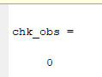
So it is observability.

2.2 Perform simulations for zero and nonzero initial conditions and report them.
Cr=198000;
Cf=470000;
cf=Cf;
cr=Cr;
Mz=1000;
lf=3.67;
lr=1.93;
m=9950;
J=5;
Iz=5;
v=50;
nu=1;
mu=nu;
a0=(Cf*Cr*(lf+lr)^2)+(Cr*lr-Cf*lf)*m*v^2;
a1=(Cf*(J+lf^2*m)+Cr*(J+lr^2*m))*v;
a2=J*m*v^2;
b0=(Cf*Cr*(lf+lr))*v;
b1=(Cf*lf)*m*v^2;
A1=[(-mu*cf-mu*cr)/(m*v) -1+((mu*cr*lr-mu*cf*lf)/(m*v^2))];
A2=[(mu*cr*lr-mu*cf*lf)/(Iz) (-mu*cf*lf^2-mu*cr*lr^2)/(Iz*v)];
A=[A1;A2];
B=[(mu*cf)/(m*v);(mu*cf*lf)/(Iz)];
C=[0 1];
D=[0];
e=[-5+8.6i,-5-8.6i];
k=place(A,B,e);
p=[-20 -20];
L=acker(A',C',p)';
L=L;
x0=[0,0];
Ahat = A;
Bhat = [B, L];
Chat=[1 0;0 1];
Dhat = [0, 0; 0, 0];
xhat0 = [5, 5];

